To meet or not to meet, that is the question

Local authority home education officers will often ask home educating parents to meet with them. Home educating parents can be confused about whether or not they should. Quite often, this confusion arises from the parent’s exposure to news about the conduct of some local authority officers in some regions. This article presents some facts which may help parents to decide.

Are local authority staff unreasonable?

Just like in any other cohort of people, there will be a normal distribution curve that can be used to describe the differing level of staff competency with respect to supporting home education. The majority do a good enough or better than good enough job and, of course, there are a few who are bad. At Education Otherwise we are aware of a tiny minority whose conduct is so bad that we do not consider it appropriate for those individuals to be working with families. These cases become widely known about very quickly and will colour the views of home educating families, even in local authority areas where the offices are good or excellent. We must emphasise that those disreputable individuals are a tiny minority amongst home education officers nationally.

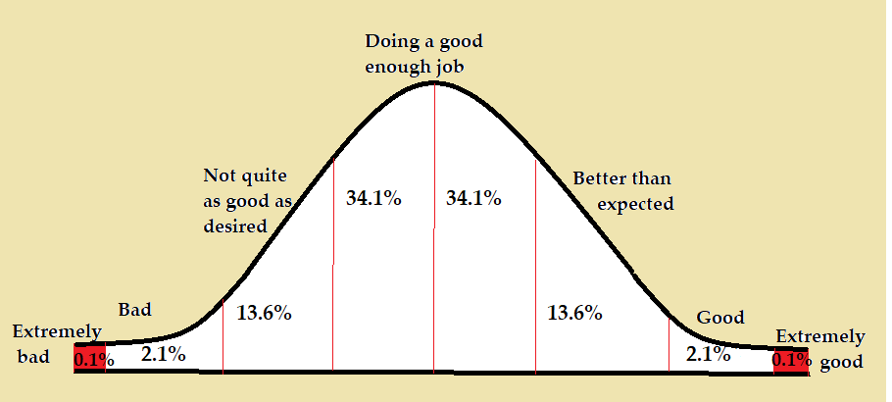

At the other end of the scale there are those education staff who are better than expected, many are good and some are extremely good as to stand out in a positive way. Our Kit Award recognises excellent service by home education officers and over 90 awards were made this year.

Are there any cases where the local authority can insist on a meeting?

We must remember that the same distribution applies to home educating parents, with the majority doing a good enough or better than good enough job. Of course, there are a few who are bad and a tiny minority whose provision is so bad that objectively, it cannot be considered appropriate for those individuals to be home educating their children. However, we must emphasise that those individuals are a tiny minority.

The local authority may ask to meet with a family at their home or elsewhere and they are perfectly entitled to ask to do so. The local authority is not, however, entitled to meet with the family in most cases. There may be extreme cases in which they may be entitled to do so, arising from legal precedent in a case where the circumstances of the family were exceptional and in whch the parents had given an undertaking to allow such visits in legal proceedings (see Regina v SQSAC, ex parte Tweedie. QBD 61 LG 464). In most cases, meetings cannot be insisted upon.

How do I know if my local authority officer is trustworthy and respectful?

The easiest way to get to know about your local authority and how its staff relate to home educating families is to join the local home education group and ask your fellow home educators. You can find your local group here: https://www.educationotherwise.org/community-portal/

Why is the local authority asking about my home education?

The local authority has a duty to act if a parent is not providing suitable education (Education Act 1996 s437). Legal precedent has found that this duty to act gives the local authority the right to make an informal enquiry of the parent in order to ascertain whether its duty is triggered:

‘Where an authority has a duty to take action in particular circumstances, it also has a duty to be alert in order to detect the possibility that those circumstances exist…The most obvious step to take is to ask the parents for information. Of course, such a request is not the same as a notice under section 37(1) of the Education Act 1944 and the parents will be under no duty to comply. However, it would be sensible for them to do so.’ (Phillips v Brown 1980, QBD NO 424/78).
Local authority education officers contact parents initially, in order to make an informal enquiry, in order to reassure themselves that the parent is doing a good enough job.

To meet or not to meet, how to answer the question.

Whether to meet the local authority officer, if they invite you to do so, is an individual choice. Education Otherwise listens to parents and we know that there are many reasons why a parent would prefer not to meet the local authority officer. However, we are equally aware that there are many who would like to do so. The following chart gives some of those reasons:

To meet or not to meet weighing up he question

What if I choose not to meet with the local authority to discuss my home education?
It is up to the parent how they provide information and each parent must decide what is best for them. You might prefer to submit an education report, a third-party report, copies of work or find an inventive method for answering the enquiry. Every method has its benefits and disadvantages. The most commonly chosen method is to write an education report. If you decide to write a report please do refer to our fact sheet on report writing which you can find here: https://www.educationotherwise.org/resources/fact-sheets/

The most important point to remember as a home educating parent is to always respond to any enquiry from your local authority. If you do not do so the authority could assume that your education provision is not suitable.

